Proof of Concept Vulnerabilities

1.stack buffer overflows
(1)
In server.c, function int server_cd(int datasock, int sockstate, char* msg) 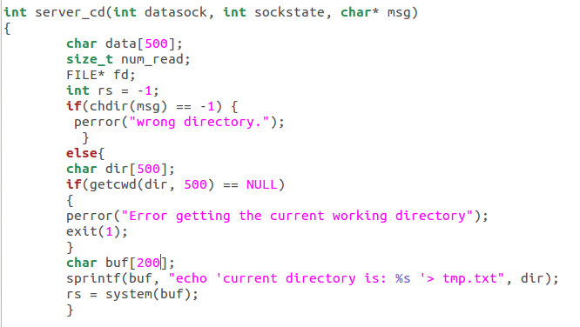
I use sprintf to send dir to buf, dir’s space is 500 but unfortunately buf’s space is only 200. So if attacker manages to input a string which length is longer then 200, he could corrupt other parts of memory. Moreover he could write some shellcode and run some malicious function.
(2)
In server.c, function int server_authentication(char*user, char*pass)
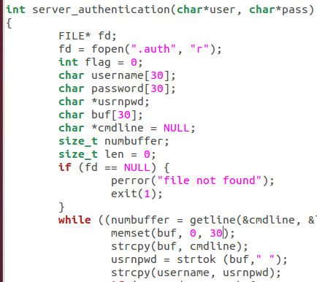
Buf’s length is only 30, but I do not restrict the capacity of pointer cmdline, if cmdline’s capacity is longer then 30 ,it would arise stack overflow. So attacker can steal .auth file and replace with a carefully designed shellcode which is longer then 30.

2.pointer corruption
(1)In server.c, function int server_authentication(char*user, char*pass)
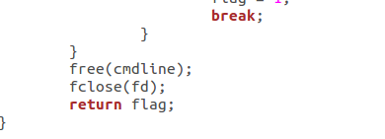
(2)In client.c, function int main(int argc, char* argv[])
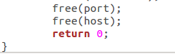

Only free pointer cmdline host and port is not enough, we need to set *cmdline, *host and *port equal to NULL, otherwise attacker can reuse these dangling pointers to corrupt memory.

3.format string
In client.c , function int main(int argc, char* argv[])
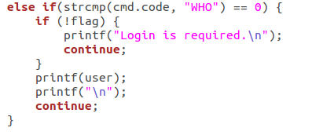
Directly using printf(user) is very dangerous, especially when user might be input by attacker, he could input something like %d to read in someplace of memory he wants to attack.

4.Command injection
- In server.c function int server_cd(int datasock, int sockstate, char* msg)
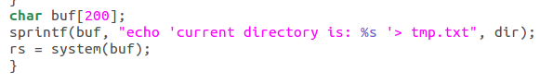
(2)In server.c function int server_service(int datasock, int sockstate, char* cmd)
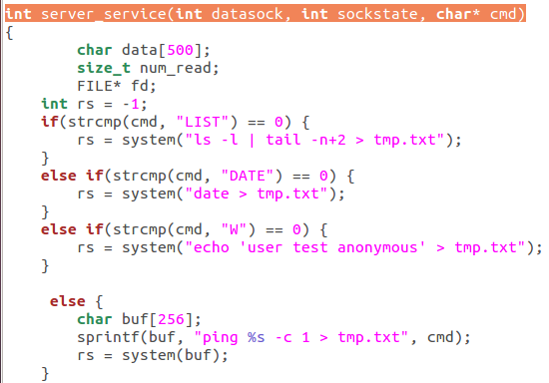
Directly using system() is very dangerous ,especially when command is decided by user. Attacker could input command like “ping www.nba.com;ls” to execute unauthorized commands.

